**Project Documentation**

**CapStone - Project**

**Mobile HR Contacts App**

***~codeRed~***

**Oleg Eremeev –** [**eremeevo@ualberta.ca**](mailto:eremeevo@ualberta.ca)

**November 13 - Dec 8, 2020**

**Project Management Plan**

**· Overview of the project:**

This capstone is a final part of the TechCareers Program, supported by the University of Alberta and Government of Alberta and Manpower. Main objective of this app is to allow HR to login to their database remotely and create or find a certain employee at any moment.

**· Project scope:**

The project will include 3-4 web pages:

1. **Log-in Page.**
   1. **Login Name**
   2. **Password**
2. **Sign UP Page.**
   1. **Name**
   2. **Email**
   3. **Password**
   4. **Confirm Password**
3. **Admin Page with Navigation Bar that consists of:**
   1. **Create Record button**
   2. **Show All Records**
   3. **Search (Out Of Scope)**
4. **Create Record Page**
   1. **Full Name field**
   2. **Email field**
   3. **Phone field**
   4. **Age field**
   5. **City field**
   6. **Department field**
5. **Show All Record**
   1. **Display All previous Records**
      1. **Full Name field**
      2. **Email field**
      3. **Phone field**
      4. **Age field**
      5. **City field**
      6. **Department field**
   2. **Search Option will be outside of main scope**
      1. **Field where user can enter a name and look up related information (out of scope)**
      2. **Field where user can enter phone number and loop up related information (out of scope)**
6. **Display All Records Page (Delete Button – Main Scope, Update Button – Main Scope )**

**· Project Schedule:**

Planning Nov 13 – Nov 14

Trello Board ToDo list Nov 15

Trello Board Due Dates for each task Nov 15

Database Tables Relations Nov 15

Start The Project APS DOTNET MVC

Design

Layout

Typography

**Requirements Specifications**

Software Stack:

ASP DotNet Core MVC

Bootstrap 4

XAMPP for MySQL Database and MSSQL

JavaScript, HTML, CSS, JQuery

**Design**

**LANDING PAGE**

Log in and Sign UP page Most likely both on the same page

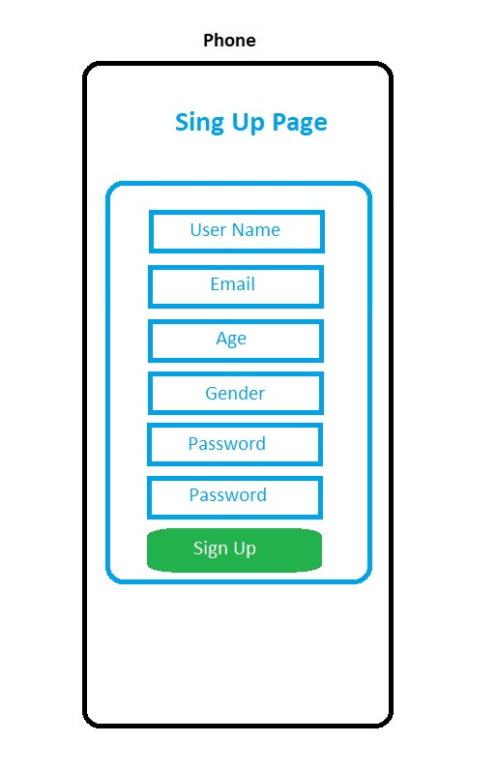Figure 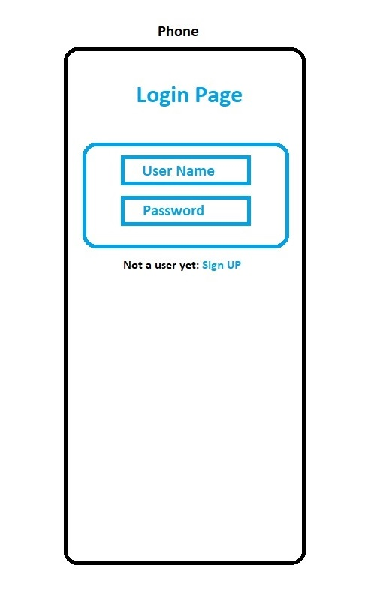

**ADMIN PAGE CREATE RECORD PAGE**

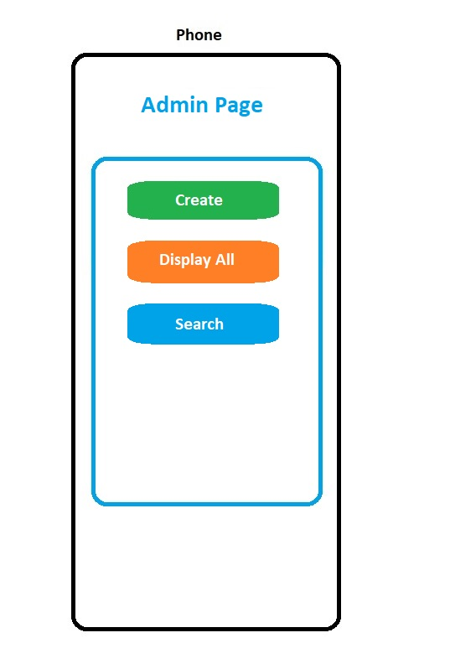Figure 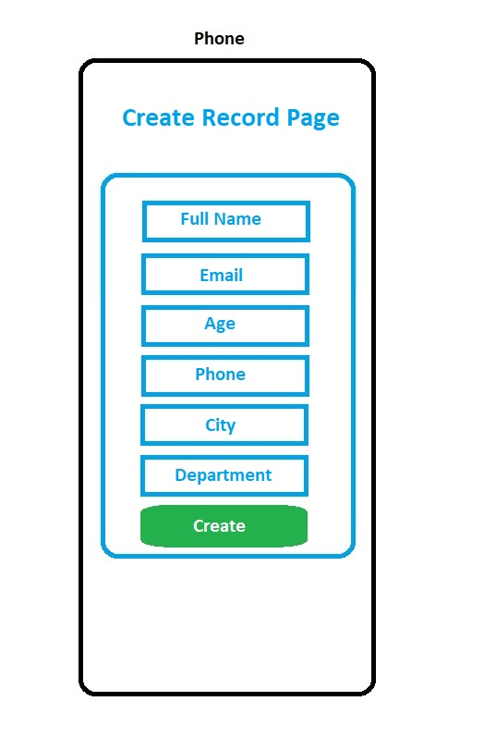

**ALL RECORDS PAGE SEARCH PAGE**

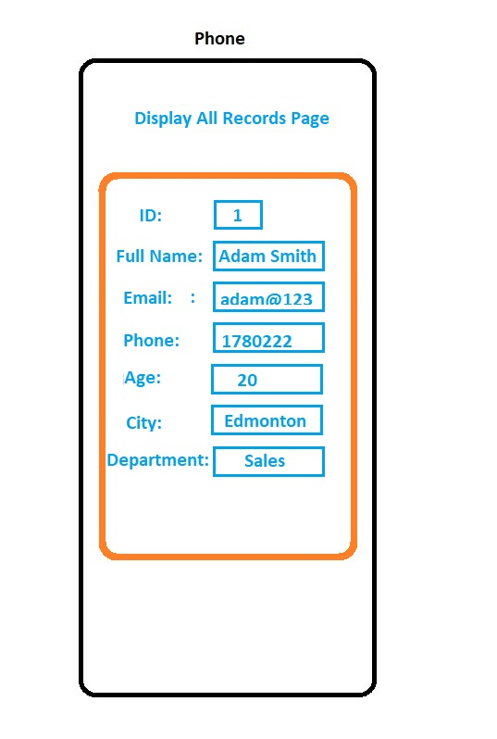Figure 